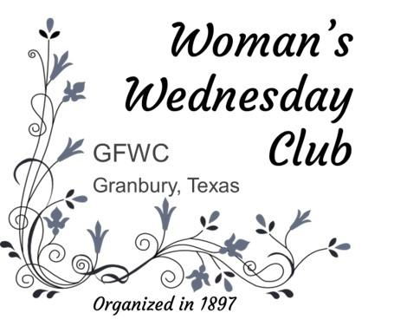
Woman’s Wednesday Club
2025-2026 Scholarship Guidelines

Each year, the Woman’s Wednesday Club (WWC) awards thousands of dollars in scholarships to students who show potential as future community leaders

ELIGIBILITY FOR WWC SCHOLARSHIPS

Applicants must be a:
- Female resident of Hood County.
.
- College sophomore, junior or senior:
- Full-time at a four-year college or university.
- Have at least a 2.5 grade point average.

- Full or part-time student returning to college after a pause.

- Full- or part-time student at Weatherford College.

- Full-time student pursuing a Graduate degree.

APPLICATION GUIDELINES

Each Applicant must:
- Meet the above eligibility criteria;
- Submit a complete Scholarship Application Packet, consisting of:
- A Scholarship Date Form.
- A personal statement of the applicant’s goals related to the applicant’s future career and the applicant’s future commitment to public/community service.
- A resume’ including college accomplishments and service.to the community.
- A college/university transcript.
- Scholarship Application Packet components 1-3 must be submitted together. The transcript (4) may be submitted separately.
- By submitting a Scholarship Application Packet, scholarship winners consent to having their names, photographs, name of college, and college major published in the WWC Newsletter and published in conjunction with the WWC Scholarship Fundraiser.

NOTE: The Scholarship Committee will not consider incomplete applications.

Woman’s Wednesday Club
2025-2026
Scholarship Data Form

Applicant’s Name:
Scholarship Type:  Check One | ___ Full-time Sophomore, Junior or Senior at College or University  ____ Full or Part-time student returning to college after a pause  ____ Full or Part-time student at Weatherford College  ____ Full-time student pursuing a Graduate degree
Applicant’s Home Address:
Applicant’s current address (if different from above):
Applicant’s Phone:
Applicant’s email:
Hood County High School:
High School Graduation Year:
Applicant’s College / University:
Applicant’s Major:
Applicant’s Minor:
Applicant’s GPA:
Month / year of projected graduation:
Student ID / Name / Address / College/University Office to Receive Funds:
Applicant’s Signature:

By submitting a Scholarship Application Packet, scholarship recipients consent to having their names, photographs, name of college, and college major published in the WWC Newsletter and published in conjunction with the Scholarship Fundraiser.

DATE FORM AND SCHOLARSHIP GUIDELINES

- Applicants may obtain the date form and scholarship guidelines via:

- Our Website: www.wwcgranbury.com

- An email request to sallytimmons1@gmail.com

- Completed application packets must be returned via:

- Email to sallytimmons1@gmail.com or

- U.S. Mail to: WWC Scholarships
% Sally Timmons
5244 Country Club Drive
Granbury, Texas 76049

2025-2026 SCHOLARSHIP DEADLINES
October 24, 2025 Committee must receive complete application packet
November 24-26, 2025 Committee will notify winners
December 3, 2025 WWC will announce winners at December’s meeting

WWC will send scholarships directly to the winning applicant’s college/university for the spring semester. If the winning applicant changes college/university for the spring semester, she must notify the Scholarship chair.

ABOUT US

The mission of the GFWC Woman’s Wednesday Club of Granbury (WWC) is to widen the outlook of women, stimulate intellectual growth, and strengthen individual efforts among its members. As part of our mission, we offer scholarships to promising women who are (i) full-time college sophomores, juniors and seniors, (ii) full-or-part-time students at Weatherford College, (iii) returning to college full or parttime after a pause, or (iv) pursuing a full-time graduate degree.
WWC is a member of the General Federation of Women’s Clubs (GFWC) and GFWC Texas. GFWC is an international women’s organization dedicated to community improvement by enhancing the lives of others through volunteer service.

Questions? TEXT Sally Timmons, Scholarship chair, at 817-964-2101

